Partner: Tim Leonard and Susie Burke

Lesson Plan: PBS Teachers:
http://www.uen.org/Lessonplan/preview.cgi?LPid=15429

Domino Theory
Curriculum Tie:  - Mathematics  6th Grade  Standard 2  Objective 1 |  | Summary:  Students will use dominos to learn about common denominators and fractions.  Main Curriculum Tie:  Mathematics - 6th Grade  Standard 1 Objective 2  Explain relationships and equivalencies among rational numbers.  Materials:  - Set of dominos (ideally double twelves, but smaller sets will work)  - Set of coins or round plastic chips  Web Sites  - Online Domino Game  Background For Teachers:  The use of dominos represents a graphical model for adding unlike fractions. A key concept for students to understand is the common denominator. A common denominator is a common multiple of two or more denominators. A multiple is the lowest number that both (or all) numbers (denominators) can “go into,” or be divided into.  In the case of adding or subtracting, unlike fractions, the Least Common Multiple (LCM) needs to be found. The dominos in this activity illustrate the need for a common or matching set of dominos in order to add. That is where we need the common denominator.  As a teacher, you can even explain the use of the term common denominator in everyday speech. For example, the common denominator in the Civil War was hatred of each side for the other. That is what was shared in common—the common cause of the war.  Intended Learning Outcomes:  1. Demonstrate a positive learning attitude toward mathematics.  Instructional Procedures:  Invitation to Learn  Kids enjoy dominos—whether playing a game or setting them up in a pattern only to tip them over. Students will use dominos to assist them in understanding addition of fractions during this activity.  Have pairs or small groups of students set up two unequal lines of dominos standing on their short end. They can use straight lines or curves—as long as the lines have an unequal amount with a difference of at least three.  When the lines are set up, have students tip them at the same time. What do they notice? Did the shorter line finish first? Of course. They are not even. One line has more than another. Explain that you will use the dominos to add unlike amounts of fractions together.  Instructional Procedures  - This activity works best with unlike fractions with small denominators. How large the fractions are depends on how many dominos you have. Pass out sets of dominos and plastic chips or coins to pairs or small groups.  - Explain that they will use the blank side of the dominos to add unlike fractions. Model the first problem with them.  Example:  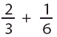  Remind students that the denominators represent the total number, in this case, of dominos. Have them arrange two lines parallel to each other that look like this, representing the denominators:  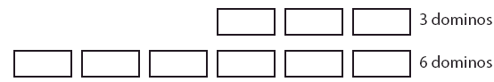  Another way to remember is to use the term “domino denominator.”  - Next, using the coins or plastic chips, place two chips on top of two dominos in the group of three, and one chip on top of one domino in the group of six, representing the numerators:    - Ask the students how many dominos they would have to add to the group of three to equal the group of six. The answer is three. Remind them that if they add three more dominos, they also need to add a chip or coin to two of them, like this:  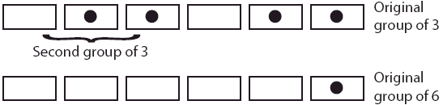  - Now that both lines have the same total amount of dominos, six, ask the students to add up all of the dominos with chips or coins on the tops. The answer is five. So, five-sixths (5/6) of the dominos have coins or chips on top of them.  - This process can be checked by adding the traditional way, as follows:  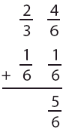  - Again, this technique is more effective with “smaller fractions,” as determined by the number of dominos and coins or chips.  - This exercise may also be used to demonstrate simple subtraction of unlike fractions. The difference being you subtract the lesser amount of chips/coins from the greater amount.  Attachments  - math.gif  - math1.gif  - dominoes.gif  - dominoes1.gif  - dominoes2.gif  Extensions:  Another activity using the dominos is done with the numbered sides. With all dominos face down, have a student (in a pair or group) turn over two dominos. On each domino, the smaller number represents the numerator, and the larger number represents the denominator. Have students practice adding and subtracting these fractions on the dominos. Paper and pencil may be needed.  Family Connections  Dominos is a popular game for many families. Many games involve grouping and patterns with a need for number sense and operations. Encourage students to play domino games with families. In the event a student has no access to dominos, at your discretion, they may check out your set.  Assessment Plan:  An ideal assessment method for this activity combines a performance test with a traditional summative test. Students, given a set of problems, model and solve equations using the dominos in this activity. This assessment would indicate conceptual understanding of the process of addition and subtraction of fractions.  Bibliography:  Research Basis  Tankersley, K. (1993). Teaching Math Their Way. Educational Leadership, 50, 12-13.  This article follows the development of a methodology of using manipulatives for elementary math that fosters discovery and positive attitudes toward math. It also reflects an increase in testing results in math.  Rust, A. L. (1999). A study of the benefits of math manipulatives versus standard curriculum in the comprehension of mathematical concepts. Knoxville, TN, ERIC 436395.  This dissertation attempted to test first graders using both standard text-book based instruction and the use of manipulatives in math. Conclusions indicated little difference in tested results, though standard curriculum methods did show slightly higher results. However, the article points out that students’ enjoyment of the different methods wasn’t studied.  Author:  Utah LessonPlans  Created Date :  Feb 27 2006 12:17 PM

