
Cyberethics, Cybersafety, & Cybersecurity Conference
October 6-8, 2005
University of Maryland
College Park
Samuel Riggs Alumni Center
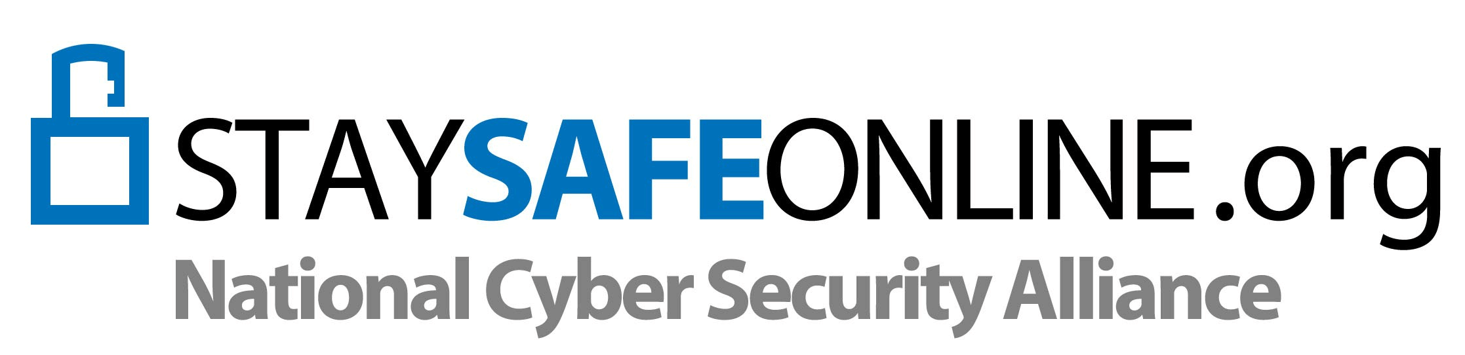
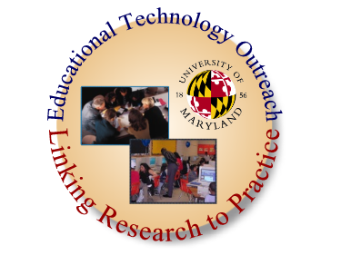
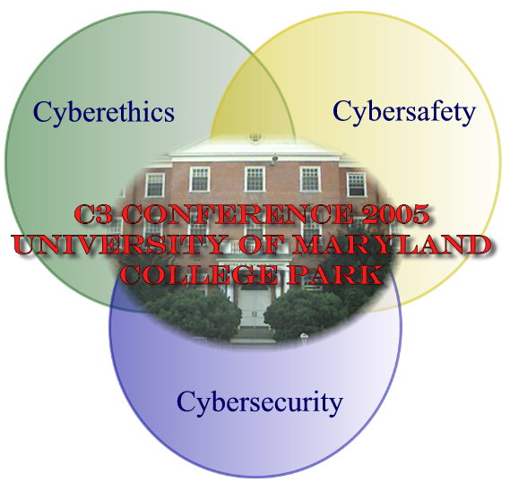
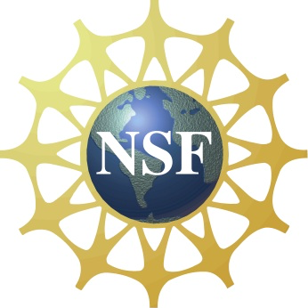

Dear Participants:
COLLEGE OF EDUCATION
Office of the Dean
Educational Technology Outreach
Educational Technology Outreach (ETO) takes great pleasure in hosting this fourth Cyberethics, Cybersafety, Cybersecurity (C3) Conference. The core mission of the C3 Conference is to inform the educational community about the ethical, legal, safety, and security implications of technology use. In the past years, ETO has sponsored a C3 Conference for local area educators - usually held in the spring or summer. This year we moved the conference to the first week in October to be part of the roll out of the new October is National Cyber Security Awareness Month initiative sponsored by the National Cyber Security Alliance (NCSA). We are particularly excited about this conference as it has been expanded with support from the National Science Foundation and the NCSA allowing pre-conference workshops from iSAFE, the Socrates Institute and Microsoft, and wonderful speakers including keynotes from former FTC Commissioner Orson Swindle III , Barbara Chung from Microsoft, and Jeff Greenspan of Database and Lan Solutions.
While our primarily goal is to provide a forum for participants to learn and share, another goal is to raise the national consciousness of current and needed awareness training and research in the areas of Cyberawareness that impact educators and students. Our speakers discuss the complexities of Cyberethics, Cybersafety and Cybersecurity and the ways the three intersect. The conference audience consists of a variety of teachers, administrators, Department of Education personnel, and IT coordinators, as well as a wide variety of local University faculty, staff and students from various disciplines: computer science, engineering, education, counseling, library science and criminal justice. The audience is as diverse and complex as the C3 topics themselves.
At the closure of the conference, we hope that each participant has left with new knowledge and insights into the vast resources that will help move this important initiative forward. We also hope participants will continue to take part in other events scheduled throughout the month of October. You can view some of these activities in this program. We look forward to seeing you again next October.
Sincerely,
Davina Pruitt-Mentle
Director, Educational Technology Outreach
College of Education
University of Maryland

October 2005
Pre-Conference Workshops
Thursday, October 6, 2005

8:00 AM – 12:00 PM Benjamin Building Room 0220

i-SAFE America's Professional Development Program (PDP)
Dina Morales, Director of Professional Development, i-SAFE America

Training for educators and law enforcement professionals to familiarize them with i-SAFE's programs and provide them with a solid foundation in Internet safety issues. On completion of the PDP, attendees are i-SAFE certified and qualified to teach the curriculum in the classroom, train others, and develop the i-SAFE program in their communities or organizations.

8:30 AM - 12:00 PM Benjamin Building Computer Teaching Lab 0306

The CyberEthics Project K-12 Simulations, Role-Plays, & Curricula
Mary L. Radnofsky CEO, The Socrates Institute, Alexandria, VA

This session provides a first look at The CyberEthics Project, a comprehensive program of K-12 instructional materials and training, including simulations, role-plays, computer games, curricula, sample surveys, and videos covering juvenile cybercrimes. These materials are being created by The Socrates Institute to teach young people personal responsibilities, consequences, safety and ethical issues regarding use of the Internet. Participants in this session will explore some of these materials and strategies covering a) Identity Theft; b) Hacking, Spreading Viruses; c) Downloading; d) Software Piracy; e) Plagiarism; f) Cyberterrorism; and g) Cyberstalking. For more on The CyberEthics Project, go to: http://socratesinstitute.org/curriculum/cyberethics.html

1:00 – 4:00 PM Computer and Space Science Bldg Faculty Technology Center - 4404
Microsoft Security Tools and Tips: Running Windows XP Safely in the
Classroom
David Norris, Productivity Advisor, Microsoft Public Sector

This session allow participants to discover the latest security enhancements for Windows XP. During this session we will explore the additional security features for Windows XP and Internet Explorer 6 provided by Service Pack 2. Attendees will learn to leverage new tools such as Microsoft Windows AntiSpyware (Beta) and the Microsoft Windows Malicious Software Removal Tool to protect students from the potential dangers of working in a connected classroom. We will also discuss how the new Shared Computer Toolkit, a free download, helps make shared lab, classroom or library computers more reliable, secure and less time-consuming to maintain.
Conference Sessions
Friday, October 7, 2005

7:45 - 8:15 AM
Great Hall
MORNING REFRESHMENTS & REGISTRATION

8:15 - 8:45 AM
Main Ballroom
WELCOME
DAVINA PRUITT-MENTLE
Director, Educational Technology Outreach - University of Maryland
EDNA MORA SZYMANSKI
Dean, College of Education - University of Maryland

8:45 - 10:15 AM
Main Ballroom
KEYNOTE
Introduction: MARY L. RADNOFSKY CEO, The Socrates Institute
Understanding and Addressing the Current Threats From Internet Access
JEFF GREENSPAN
President of Database & LAN Solutions

10:15 - 10:30 AM
BREAK

10:30 - 11:30 AM
Main Ballroom
SPEAKER Introduction: RODNEY PETERSEN
EDUCAUSE Policy Analyst & Security Task Force
The 5-Step Security Checkup
BARBARA CHUNG
Senior Technology Specialist, Education Security Advisor
Microsoft Corporation

11:30 - 11:45 AM
BREAK

11:45 AM - 12:45 PM
Room 1
PRESENTATION
Protecting Sensitive Information and Keeping Your Identity Your Own
AMY GINTHER
Director, Project NEThics - University of Maryland

Room 2
PANEL
Security Practices Educator/Administrator/Home User Perspective
Moderator: ROBERT MAXWELL
Lead Incident Response Handler, OIT Security
University of Maryland

Conference Sessions
Friday, October 7, 2005

12:45 - 1:00 PM
BREAK

1:00 - 2:30 PM
Main Ballroom
KEYNOTE LUNCHEON Introduction: RON TEIXEIRA
Executive Director, National Cyber Security Alliance

ORSON SWINDLE III
Senior Policy Advisor
Center for Information Policy Leadership at Hunton & Williams

2:30 – 2:45 PM
BREAK

2:45 – 3:30 PM
Room 1
PRESENTATION
Keeping Kids and Teens Safer on the Internet TRACI CARRIER Marketing and Research Coordinator, NetSmartz Workshop

Room 2
PRESENTATION
Empowering Youth to be Safe Online, In the Classroom and Beyond
CAROLYN WALPOLE
Director of Education, i-SAFE America
LORI ROUNDS
Director of Technology, The Bullis School

3:30 PM
Wrap Up and Adjourn
Conference Sessions
Saturday, October 8, 2005
8:30 AM
Great Hall
MORNING REFRESHMENTS & REGISTRATION

9:00 – 9:15 AM
Main Ballroom
WELCOME
DAVINA PRUITT-MENTLE
Director, Educational Technology Outreach - University of Maryland

9:15 - 10:15 AM
Main Ballroom
KEYNOTE
Social, Ethical, Legal, and Human Issues: Insights into NETS-T VI
MILA FULLER
Director of Strategic Initiatives
International Society for Technology in Education (ISTE)

10:15 - 10:30 AM
BREAK

10:30 - 11:15 AM
Main Ballroom
PRESENTATION
Online Bullying: Prevention, Protection, Detection and Follow-up
AMY GINTHER: Director, Project NEThics - University of Maryland

11:15 AM – 12:15 PM
Main Ballroom
PRESENTATION
Interactive discussion on Computer Security on Educational Networks
AJAY GUPTA
CISSP, Faculty Computer Science, Director of Security Services
Prince George's Community College

12:15 - 1:30 PM
LUNCH – ON YOUR OWN

1:30 - 2:30 PM
Main Ballroom
PRESENTATION
The CyberEthics Project K-12 Simulations, Role-Plays, & Curriculae
MARY RADNOFSKY
CEO, The Socrates Institute

Room 2
Empowering Youth to be Safe Online, In the Classroom and Beyond
DAVID POEHLMAN
IT Accessibility in Education Coordinator,: MD Technology Assistance Program

* In an effort to allow maximum audience attendance, Plagiarism in the 21st Century has been canceled, but materials on this important topic have been included in your resources.
Conference Sessions
Saturday, October 8, 2005

2:30 – 2:45 PM
BREAK

2:45 – 3:45 PM
Main Ballroom
PRESENTATION
Implementing Effective Cybersecurity JOHN POTTER & JOSEPH RENARD
Consortium for School Networking (CoSN)

Room 2
PRESENTATION
Keeping Kids and Teens Safer on the Internet TRACI CARRIER Marketing and Research Coordinator, NetSmartz Workshop

Room 3
PRESENTATION
Empowering Youth to be Safe Online, In the Classroom and Beyond
DINA MORALES
Professional Development Manager, i-SAFE America
LORI ROUNDS
Director of Technology, The Bullis School
3:45 PM
Adjourn & Closure

Speaker Biographical Sketches

Jeff Greenspan

President

Database & LAN Solutions
Jeff Greenspan is the President of the technical and security services firm, Database & LAN Solutions in Burke, VA which he founded in 1986. Jeff is an engineering graduate of The Johns Hopkins University. Jeff is also one of the founders and an Officer of a national organization called THISA - Trusted Healthcare Information Solutions Alliance which provides Identity and Access Management solutions to enterprise organizations in the healthcare, financial and educational fields.
Jeff is an accomplished speaker and security expert with the unique ability to present technical concepts in an interesting and understandable way. Specifically, this presentation is designed to educate both non-technical users, technical network administrators and organization leaders and management about the current state of technology threats. The rapidly changing threat matrix requires constant examination and evaluation and a multi-layered approach to protection from both external and internal threats (inside and outside your classroom and local school system infrastructure). We overlay this threat paradigm with the requirements and mandates of compliance regulations, and then discuss both common sense and technology-based methods for protecting teachers, students, school members and your local school system from those threats.

Barbara Chung

Security Advisor for Education

Microsoft Corporation
Barbara Chung has been with Microsoft for the past seven years, working with organizations across the span of US industries mitigate the complex challenges that they face in the current security environment. She has presented for the Department of Homeland Security, at many state and other industry security events and expert panels. For two years she maintained a community of security professionals representing more than 600 organizations in diverse industries, ensuring their exposure to developing technologies in the field of security, and assisting them in understanding and accessing Microsoft’s security resources. She has directly supported Microsoft customers in crisis, helping them develop appropriate response plans, coordinating resources to assist in them in stabilizing, and ultimately improving their security status and response abilities.

Orson Swindle

Senior Policy Advisor: Center for Information Policy Leadership at Hunton & Williams

Former Commissioner of the Federal Trade Commission
Orson Swindle joined Hunton & Williams on September 15, 2005. Until June 30, 2005, He served as a Commissioner on the Federal Trade Commission having begun his tenure on December 18, 1997. The Federal Trade Commission is the Federal Government’s principal law enforcement agency for antitrust and consumer protection laws dealing with mergers and acquisitions; fraudulent, deceptive and illegal business practices; information system privacy and security; and business and consumer education.
As a Commissioner, he was engaged in decision making during the peak of the merger and acquisition wave of recent years; privacy and security concerns driven by the developing information economy and electronic commerce; and international policy deliberations and presentations on these issues. Commissioner Swindle played a leadership role in addressing information system security and privacy concerns in both domestic and international settings through the Organization for Economic Cooperation and Development and the Asia Pacific Economic Cooperation organization. He has testified before numerous Congressional Committees in his capacity as a presidential-appointed Assistant Secretary of Commerce under President Reagan and most recently as a Commissioner at the Federal Trade Commission.
Mr. Swindle served in the Reagan Administration from 1981 to 1989 directing financial-assistance programs to economically distressed rural and municipal areas of the country. As Assistant Secretary of Commerce for Economic Development, he managed the Department of Commerce’s national economic development initiatives directing seven offices across the country. Prior to being Assistant Secretary, Mr. Swindle served the Reagan Administration as the Georgia State Director of the Farmers Home Administration for the U.S. Department of Agriculture managing programs for financing rural housing, community infrastructure, businesses, and farming.
In 1992, Mr. Swindle was national spokesperson for Ross Perot’s grassroots presidential campaign, becoming the first national leader of United We Stand America. In 1993, he worked with former cabinet secretaries Jack Kemp and William Bennett, former Congressman Vin Weber, and Ambassador Jeanne Kirkpatrick to form Empower America. In 1994 and 1996, he was the Republican candidate for Congress in Hawaii’s 1st Congressional District.
Mr. Swindle had an extraordinary military career. While a Marine aviator serving in South Vietnam on November 11, 1966, Mr. Swindle was shot down over North Vietnam, flying his 205th, and what was to have been his last, combat mission.
He was captured by the North Vietnamese and held Prisoner of War in Hanoi for the next six years and four months. On March 4, 1973, he was released from captivity at the conclusion of American involvement in the Vietnam War.
Mr. Swindle retired from the U.S. Marine Corps in 1979 with the rank of Lieutenant Colonel. He has been awarded over 20 military decorations for valor in combat include two Silver Stars, two Bronze Stars, two Legions of Merit and two Purple Hearts.
Mr. Swindle has been recognized for his leadership in his various professional capacities, for example, as the 2005 RSA Conference Award for Public Policy by the Cyber Security Industry Alliance, the 2004 Privacy Leadership Award by the International Association of Privacy Professionals, and the 2003 WW II Marine Raiders “Point Man” Award for his lifetime of leadership and “pointing the way.” He is in constant demand as a speaker on public policy, particularly on the topics of information system security and privacy, as well as on motivation, overcoming adversities, and executive leadership. His audiences include those from the legal and business communities, military, academia, politics, public service and civic groups in both domestic and international settings. He has been the subject of hundreds of news articles and stories and has dozens of appearances on virtually every television and cable network news show.
Mr. Swindle earned a Bachelor of Science degree in Industrial Management from Georgia Tech in 1959 and a Master of Business Administration from Florida State University in 1975.
He was born in Thomasville, Georgia, on March 8, 1937, and grew up in Camilla, Georgia. He and his wife, Angie, live in Alexandria, Virginia.

Links
September
26. University of Wisconsin- Cyber Security Boot camp - http://www.educause.edu/esem051

October
- Learn more about protecting your personal information. - http://www.staysafeonline.info/practices/one.html
- Learn about “phishing “ and who you're dealing with online - http://www.staysafeonline.info/practices/two.html
- Learn what Anti-Virus Software is and What to Look For and Where to Get It - http://www.staysafeonline.info/practices/three.html
  - TappedIn discussion on Cyberethics, Cybersafety, and Cybersecurity – 8PM - http://tappedin.org/tappedin/do/CalendarAction?ROOM_ID=&Zone=&Month=9&Year=2005&state=displayExtCalendar
- Be sure to set up your operating system and Web browser software properly, and update them regularly - http://www.staysafeonline.info/practices/four.html
- Use strong passwords or strong authentication technology to help protect your personal information - http://www.staysafeonline.info/practices/five.html
- Back up important files. - http://www.staysafeonline.info/practices/six.html
  - University of Maryland/NCSA C3 Conference - http://www.edtechoutreach.umd.edu/C32005/
  - Texas State Cyber Security Awareness Day 2005 - http://www.tr.txstate.edu/security/csad2005/
- Learn what to do if your computer gets a virus - http://www.staysafeonline.info/practices/seven.html
  - University of Maryland/NCSA C3 Conference - http://www.edtechoutreach.umd.edu/C32005/
- Protect your children online. - http://www.staysafeonline.info/practices/eight.html
  - University of Maryland/NCSA C3 Conference - http://www.edtechoutreach.umd.edu/C32005/
- Visit the Internet Fraud Complaint Center (IFCC) to see how the FBI fights computer criminals - http://www.ifccfbi.gov/index.asp
- Download a free Security Awareness poster from Arizona state - http://security.arizona.edu/posters.html
  - TappedIn discussion on Cyberethics, Cybersafety, and Cybersecurity – 8PM - http://tappedin.org/tappedin/do/CalendarAction?ROOM_ID=&Zone=&Month=9&Year=2005&state=displayExtCalendar
- Find ways to prevent, locate or uninstall invasive spyware on your computer - http://spotlight.getnetwise.org/spyware/
- Learn about tips and tools to protect your privacy while surfing across the Web. - http://privacy.getnetwise.org/browsing/
  - University of Florida IT Awareness Day 2005 - http://www.itsa.ufl.edu/
- Discover how to safely shop online while limiting the amount of information you share with others. - http://privacy.getnetwise.org/shopping/
- Take the self guided security test - http://www.staysafeonline.info/basics/quiz.html
- View a short video tutorials for activating an e-mail filters - http://spam.getnetwise.org/tools/filter

- Read through the Trouble with hacking - http://www.cybercrime.gov/rules/reckless.htm
- Read About Federal Computer Crime Cases Involving Teens. - http://www.cybercrime.gov/cases.htm
  - TappedIn discussion on Cyberethics, Cybersafety, and Cybersecurity – 8PM - http://tappedin.org/tappedin/do/CalendarAction?ROOM_ID=&Zone=&Month=9&Year=2005&state=displayExtCalendar
- Read about how computers have been used in crimes - http://www.cybercrime.gov/
  - Educause – Cyber Security Awareness and Education Workshop - http://www.educause.edu/Browse/645?PARENT_ID=639
- Learn some basic tips to prevent unwanted junk e-mail from filling your inbox. - http://spam.getnetwise.org/tips/
- Read There’s one more talk you need to have… - http://www.cybercrime.gov/onemoretalk.htm
- Take the Legal or Illegal Interactive Quiz - http://www.bsa.org/usa/events/Test-Your-Software-Piracy-IQ-Quiz.cfm
- Read about online shopping tips before the holidays begin - http://www.ftc.gov/opa/2004/11/holidayshop.htm
- Visit CyberSmart to read the top Cybersecuirty Tips - http://www.cybersmart.org/for/top_ten.asp
- Read the most recent CSI/FBI survey findings (2005) - http://www.cybercrime.gov/CSI_FBI.htm
  - TappedIn discussion on Cyberethics, Cybersafety, and Cybersecurity – 8PM - http://tappedin.org/tappedin/do/CalendarAction?ROOM_ID=&Zone=&Month=9&Year=2005&state=displayExtCalendar
- Investigate essential steps to help protect your PC - http://www.microsoft.com/
- Learn the difference between Trojans, spyware and adware- Visit Webopedia online dictionary for computer and Internet technology definitions (http://www.webopedia.com/) or skim report (http://xforce.iss.net/xforce/threat_insight_quarterly/index.php)
- Visit the Federal Trade Commission, at ftc.gov. to learn more about what to do to avoid scammers taking advantage of you through an Internet auction, when you're shopping online - http://www.ftc.gov/bcp/conline/pubs/online/auctions.htm
- Download a security poster - http://www.cybersmart.org/for/students.asp
- Test your computer's exposure to online security threats and learn how to make your computer more secure - http://security.symantec.com/sscv6/home.asp
- Use the Wikipedia to learn more about computer viruses - http://en.wikipedia.org/wiki/Computer_viruses
- View an online video, take the security quiz or visit the other resources from George Mason’s IT security resource bank - http://itu.gmu.edu/security/practices/

Edna Mora Szymanski

Dean – College of Education

University of Maryland
Edna Mora Szymanski is the Dean of the College of Education at University of Maryland, College Park. Previously, she served in a variety of capacities at University of Wisconsin - Madison, including professor in the Department of Rehabilitation Psychology and Special Education, department chair, associate dean, director of the Rehabilitation Research and Training Center on Career Development and Advancement, and chair of the campus committees on retirement and disability. Her major areas of scholarship have focused on disability and career development, rehabilitation counselor education, and research instruction. Dr. Szymanski's most influential research demonstrated the relationship of rehabilitation counselor education to employment outcomes of people with severe disabilities. Dean Szymanski has authored or co-authored numerous refereed articles and book chapters and received several national awards for her research, including three from the American Counseling Association, three from the American Rehabilitation Counseling Association, one from the American Association of Counselor Education and Supervision, and one from the National Council on Rehabilitation Education.

Davina Pruitt-Mentle

Director, Educational Technology Policy, Research, and Outreach

College of Education

University of Maryland
Primary responsibilities include providing professional development opportunities for educators through workshops and graduate courses, many of which are run on line, and providing support for grant initiatives, faculty, departmental, and college projects that advance effective learning and teaching through technology integration.
Extensive experience in the research, development and delivery of educational media, including computer software, multimedia, distance learning and print materials. Served on the advisory committee for the national TSSA standards (Technology Standards for School Administrators) and Partnership for 21st Century Skills, served as a member of the Committee on Technology in Education (COTE) which developed the Maryland State Plan for Technology, and presently serves on the Maryland State Technology Plan Advisory Committee, the Maryland TL8 Advisory Council, the Maryland Online Technology Profiles Consortium, Prince George’s County Chamber of Commerce & Education and Workforce Steering Committees, and serves as the Education Chair for the Maryland and Prince George’s County Technology Council.
Major research and development interests have focused on the role of distance learning in education, particularly cultivating the Internet as an environment in which to conduct professional development (PD) opportunities, and educational technology evaluation and policy analysis. Other research investigates cultural differences towards technology use; the impact of technology on low income communities/populations and the policies that play critical roles in leveling the technology playing field. A main initiative within the PD portfolio involves educator and student knowledge of Cybersecurity, Cybersafety and Cyberawareness. Several initiatives have been put in place to include an annual C3 conference, C3 workshops and graduate level courses, on-line tutorials and the National Cyber Awareness month (April) and National Cybersecurity month (October) interactive calendars. Other research initiatives focus on constructivist learning and teaching via technology, through the Young Scholars Mindtools Program, Digital Fluency curriculum and professional development through gaming theory.

Traci Carrier

Marketing and Research Coordinator

The Netsmartz Workshop
Traci Carrier is the Marketing and Research Coordinator for the NetSmartz Workshop, a program of the National Center for Missing & Exploited Children (NCMEC) and Boys & Girls Clubs of America (BGCA).
Ms. Carrier works with educators, law enforcement, and local and state government officials to implement NetSmartz into schools and communities across the country. She also assists corporate sponsors with the development of Internet safety initiatives. Prior to working at NCMEC, Ms. Carrier lived in Brazil participating in various community service projects, including, “Helping Hands,” and volunteering at the AGAPE School for Handicap Children. Ms. Carrier holds a B.A. in American Studies.

Mila Fuller

Director of Strategic Initiatives

International Society on Technology in Education
Ms. Fuller is responsible for helping the CEO in establishing and maintaining strategic alliances. She also assists with identifying and exploring partnerships with institutions, agencies and other organizations to further the ISTE mission and to address technology in teacher quality. Mila currently serves as an adjunct assistant professor of education at the University of Maryland University College (UMUC), and is Past-President of the ISTE affiliate, MICCA-An Association in Maryland for Educators Using Technology. Mila is based out of ISTE’s Washington, DC Office, and has provided a variety of national and international presentations focused on improving teaching and learning by advancing the effective use of technology in education.
Prior to joining ISTE, Mila served as a district-level Coordinator for Technology Leadership, Program Manager for the Maryland Technology Academy Satellite Programs of Baltimore City, Adjunct Faculty of Education for the College of Notre Dame of Maryland, University of Maryland at College Park, and 4th/5th grade teacher. Mila also served as a member of the Committee on Technology in Education (COTE) which was responsible for the development of the Maryland State Plan for Technology. Mila earned a Master of Arts in Leadership in Teaching with an endorsement in Administration & Supervision from the College of Notre Dame of Maryland, and is currently enrolled in a Doctoral Program at Towson University in Maryland.

Amy Ginther

Coordinator, Policy Development and Education

Project NEThics
Amy Ginther’s responsibilities at Project NEThics include coordinating responses to incidents of computing resources misuse in consultation with the Project NEThics Associates, and promoting the acceptable use of computing resources through outreach to the campus community. She is also charged with identifying and researching information technology policy issues and working to develop, draft and implement IT policies.
Ms. Ginther has a Master's degree in College Student Personnel Services in Higher Education from the University of Vermont, and a Bachelor's degree in journalism from Marquette University. Prior to working for Project NEThics she worked for the Office of Judicial Programs and Student Ethical Development at the University of Maryland as the Assistant Director for Academic Integrity. Before coming to Maryland, she served in various roles in residential life departments at Carnegie Mellon University, Mankato State University, and the University of California-Davis.

Otto Gonzalez

Coordinator, Instructional Technology

University of Maryland

Mr. Gonzalez heads the Instructional Technology Support for the College of Education at the University of Maryland. This includes the circulation desk, classroom labs, classroom and network support, and managing the OIT support contract.

Ajay Gupta, CISSP
Faculty - Computer Forensics
Director of Security Services
Prince George's Community College

Mr. Gupta is a CISSP certified Information Security Professional with over 10 years experience in Information Security as well as Computer Forensics and Secure Wireless Communications. Mr. Gupta has been involved in professional projects for local and global corporations, government agencies and non-profits at both the hands-on and management level. In addition to running Gsecurity, Mr. Gupta also serves on the Faculty of Golden Gate University, Champlain College, and Prince George’s Community College where he is also the Director of IT Security. He serves as an invited lecturer for numerous Public and Private Organizations across the globe. Mr. Gupta has authored, Hack I.T. * Security through Penetration Testing, published in February 2002, and Defend I.T. * Security by Example, published in May 2004, discussing case studies of security projects ranging from disaster recovery to implementing intrusion detection systems, developing security policy to securing an 802.11 wireless communications network.

Robert Maxwell, CISSP

Lead Incident Response Handler

OIT Security, University of Maryland
Mr. Maxwell as been in IT for over 10 years, with the last six years focused on IT Security. He joined the University System of Maryland in 2001, and has been at the College Park Campus, since February.

Dina Morales

Professional Development Manager

i-SAFE America
Dina Morales is a Professional Development Manager for i-SAFE America, a non-profit organization funded by Congress to bring an Internet Safety Program to schools and communities in all 50 states and Department of Defense schools around the world. She works to expand the i-SAFE presence, promoting their education and outreach programs across the United States, in conjunction with various state-level education organizations, law enforcement agencies, and FBI field offices.
Dina Morales has over 12 years of experience in the training field. She has previously held Corporate Training Manager, Chief Corporate Trainer and Director of Specialized Programs positions both in the United States and abroad. Recently, she served on the Executive Board of the Nebraska (ASTD) American Society for Training & Development as Vice President of Professional Development 2004-2005. She received her Bachelors degree in Psychology and is currently working on completing her MBA. Dina speaks several languages and also has a black belt in Tae Kwon Do, instructing both children and adults in self-defense and martial arts.

David Norris

Productivity Advisor

Microsoft Public Sector
Mr. Norris is the New York City based Education Productivity Advisor for Microsoft's Education Solutions Group. He provides workshops and training to Higher Education and K-12 institutions throughout the East coast, demonstrating integration of Microsoft Desktop Solutions into faculty curriculum. Prior to working with Microsoft, Mr. Norris served as a Web Developer for Thomson Financial Investor Relations. He holds a BA from Virginia Tech.

Rodney J. Petersen
Policy Analyst and Security Task Force Coordinator
EDUCAUSE
Rodney Petersen is a Policy Analyst with EDUCAUSE and the Coordinator of the EDUCAUSE/Internet2 Computer and Network Security Task Force. He is the co-editor of "Computer and Network Security in Higher Education" published in October 2003 as part of the EDUCAUSE Leadership Strategies Series. He is also the author of "A Framework for IT Policy Development" published in EDUCAUSE Review and is a founding member of the Association of College and University Policy Administrators. He was formerly the Director of IT Policy and Planning in the Office of the Vice President and Chief Information Officer at the University of Maryland where he was the founder of Project NEThics - a group whose mission is to ensure responsible use of information technology through user education and enforcement of acceptable use guidelines. He received his law degree from Wake Forest University. His research and writing interests include information security, copyright ownership and use of copyrighted materials, privacy and fair use information practices, censorship and freedom of speech, and institutional policy development for the ethical and appropriate use of information technology in higher education.

David Poehlman

IT Accessibility in Education Coordinator

MD Technology Assistance Program

David Poehlman is an active participant in efforts concerning the accessibility of Electronic & Information Technology ("E&IT") such as the "World Wide Web Consortium's Web Accessibility Initiative's Protocols and formats working group. Mr. Poehlman works on projects both with government and industry and provides training and technical assistance as well as software and web page auditing and remediation assistance. He also provides guidance in accessibility to private industry through technology testing and dialog.

His current activities include: Working as the IT Accessibility in education Coordinator Of the Maryland Technology Assistance Program, expanding his business activities and participating in ongoing efforts of the World wide Web Consortium's Web accessibility Initiative. Mr. Poehlman has been an active participant in the technology access field since 1991, has served on several advisory boards and uses assistive technology in his daily work.

Mary L. Radnofsky

President and CEO

The Socrates Institute
Dr. Radnofsky has recently written a biotechnology curriculum for grades 7-12 for The Biotechnology Institute, and an early childhood curriculum in morals education for The Silver Grace Hope Foundation. Prior to that, she worked on K-12 astronomy curricula for a NASA grant related to the size of the Solar System and an unmanned mission to the planet Mercury. Previously, she designed educator workshops and instructional materials in interdisciplinary teaching for a K-6 project, "Vision and the Scientific Habit of Mind" conducted with international partners in France and Sweden.
She earned her doctorate in Education and Human Development from Vanderbilt University, her Masters Degree in French Literature from the Université de Provence, France, and her Bachelor’s Degree in English from the University of Houston.
Her publications are focused in the areas of interdisciplinary curriculum, foreign language learning, and qualitative research. She is teacher-certified, bilingual (French/English), and has spoken at numerous national and international conferences, on radio and on TV regarding interdisciplinary education and curricula.

David Rossell
Senior Network Administrator
The Bullis School
David Rossell has worked in technology for independent schools since 1997, in environments ranging from a small rural boarding school to large urban day schools. Currently, he is senior network administrator at the Bullis School in Potomac, Maryland.

Lori Rounds
Director of Technology
The Bullis School

Lori Rounds is a University of Maryland alumnus and the IT Director at the Bullis School in Potomac, Maryland. She holds a M.S. in Instructional Technologies from Virginia Tech. She has presented at conferences on the state, national and international levels. She was recipient of the MICCA 2003 Maryland Outstanding Technology Leader in Education award as well as the ISTE 2003 Outstanding Leader in Technology Education award. She currently serves on the MICCA executive board. She is a certified i-Safe educator.

Ron Teixeira
Executive Director
National Cyber Security Alliance

Ron Teixeira serves as executive director of the National Cyber Security Alliance, the nonprofit public-private partnership that serves as the go-to resource for cyber security awareness and education for home user, small business, and education audiences.

Carolyn Walpole

Director of Education

i-SAFE America

Carolyn Walpole, M. Ed ended her 23-year multi-age teaching career to become Director of Education & Curriculum Development for i-SAFE America. Under her direction, the i-SAFE Internet safety curriculum has become a dynamic collection of standards-based, age appropriate teaching and learning activities for grades K-12. Recent projects include a universal program for global cyber safety education implementation, content for Court TV’s Choices and Consequences, and the Activate Your Mind: Protect Your Ideas initiative: part of the U.S. Department of Justice’s Task Force on Intellectual Property. Carolyn has presented on the topic of Internet safety at conferences worldwide including NECC, FETC, NSBA, and conferences held by DoDEA, and the Oxford Internet Institute, Oxford University.
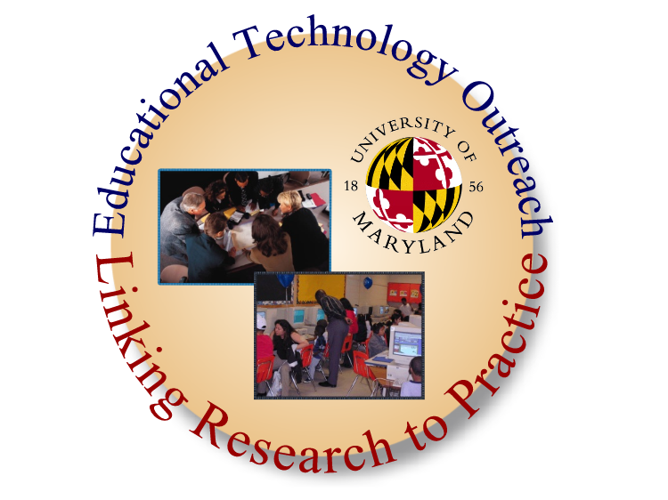
About Educational Technology Outreach
ETO was created to help facilitate effective uses of technology to educators at all levels by providing research-based applied curricular experiences in Instructional Technology and Educational Technology Policy.
Educational Technology Outreach extends the University of Maryland College of Education expertise to you by providing opportunities focusing on the following areas:

Professional Development

Curricular Reform

Evaluation and Assessment

Research and Dissemination

Collaboration

For more information, visit: www.edtechoutreach.umd.edu
About the College of Education
The College of Education at the University of Maryland is ranked 22nd in the nation among the top colleges of education by U.S. News & World Report for 2006. Offering undergraduate, master’s and doctoral degrees, the College of Education provides research- and practice-oriented programs through its six departments: Counseling and Personnel Services, Curriculum and Instruction, Education Policy and Leadership, Human Development, Measurement, Statistics and Evaluation, and Special Education. Educational programs are accredited and approved by the following: National Council for Accreditation of Teacher Education, Maryland State Department of Education, American Psychological Association, Council on Accreditation of Counseling and Related Educational Professions, and Council on Rehabilitation Education.
For more information, visit: www.education.umd.edu
About the University of Maryland
The University of Maryland is the flagship institution of the University System of Maryland. With a mandate to become nationally and internationally recognized for research and the advancement of knowledge, the university serves as the primary statewide center for graduate education and research and offers an extensive array of services and programs to state government, business, and industry. Founded in 1856, the university will pay tribute to its past and its future during its year-long 150th Anniversary celebration. From pre-Civil War roots as the state’s first agricultural college and one of America’s original land grant institutions, today the University of Maryland is a public research university ranked in the nation’s Top 20. The University of Maryland is strategically located in the thriving Baltimore-Washington, D.C. corridor, one of the most prosperous and fastest growing areas in the United States.
For more information, visit: www.umd.edu

Notes

Cyberethics, Cybersafety, & Cybersecurity Conference
We would like to thank the following sponsors for their support:

National Cyber Security Alliance – Keynote Luncheon

NSF – Conference

i-SAFE America – Workshop and Speaker
Microsoft – Workshop and Speaker
Socrates Institute – Workshop and Speaker

University of Maryland – Office of Information Technology/Project NEThics – Computer/Facilities/Logistic Support

Speakers:
Prince George’s Community College
Maryland Technology Assistance Program
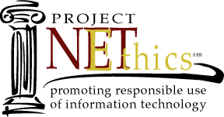
National Center for Missing and Exploited Children/Boys and Girls Clubs of America
Consortium for School Networking

International Society for Technology in Education

For more information about
National Cyber Security Awareness Month: www.staysafeonline.org
For K-12 Activities:
www.edtechoutreach.umd.edu/cyberawareness.html
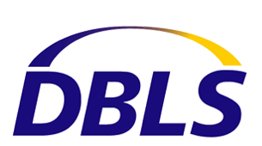Keynote Speakers
Jeff Greenspan - Database and Lan Solutions
Orson Swindle III – Hunton and Williams
Barbara Chung – Microsoft
